**B. Planning the Project**

**Project Management Life-Cycle**

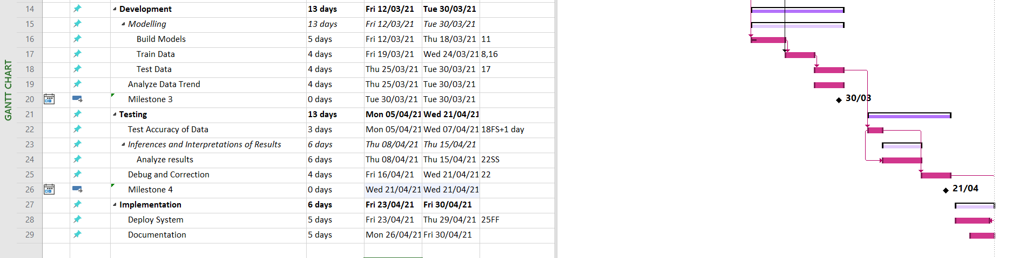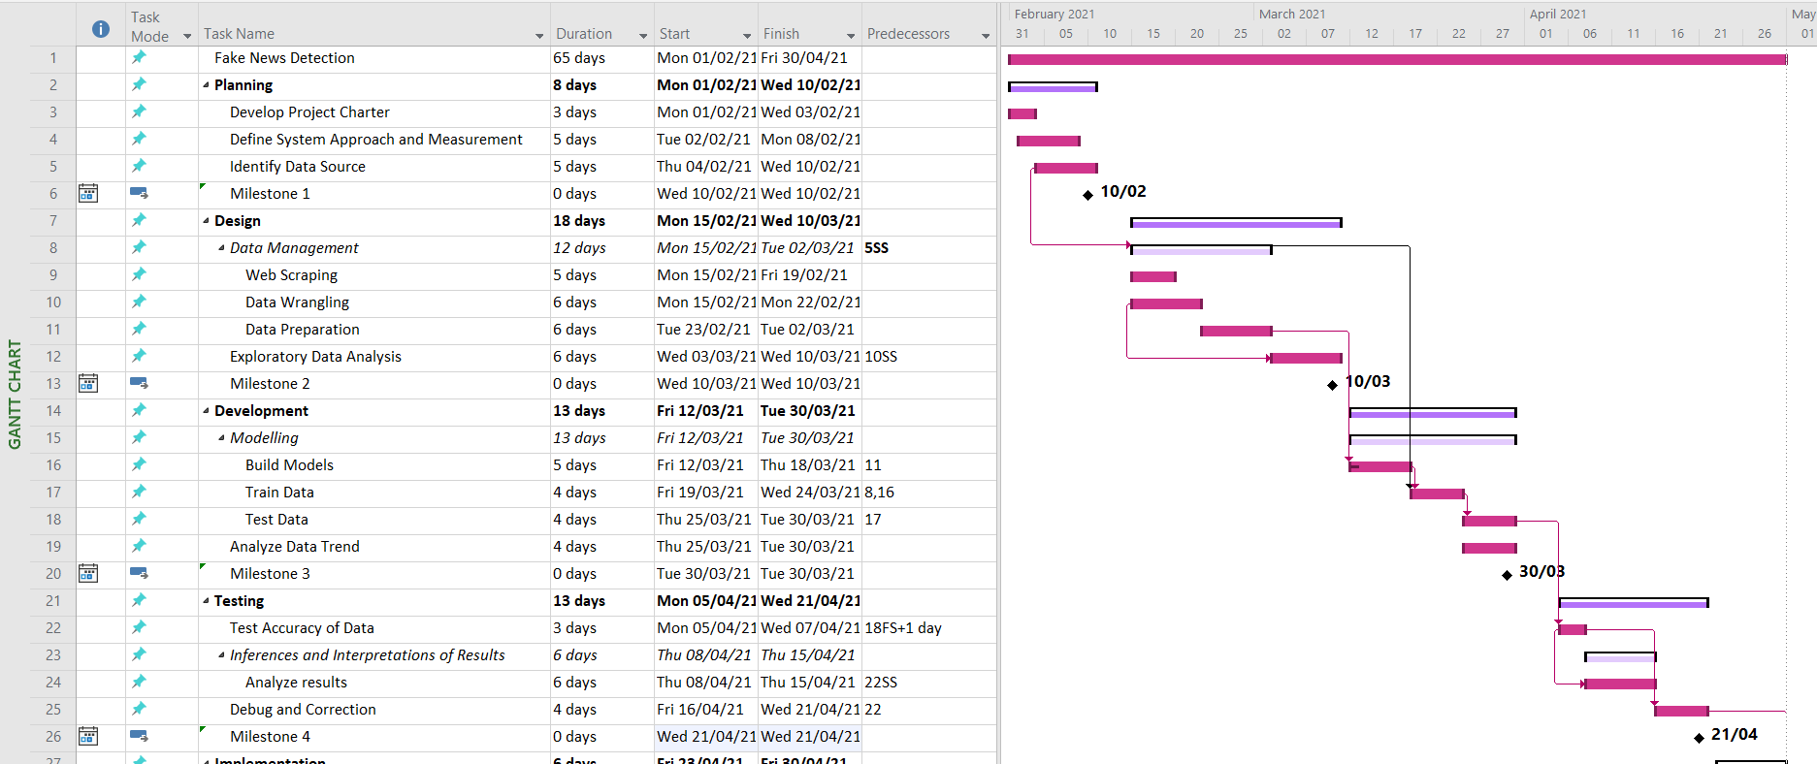

Figure 1 Gantt Chart

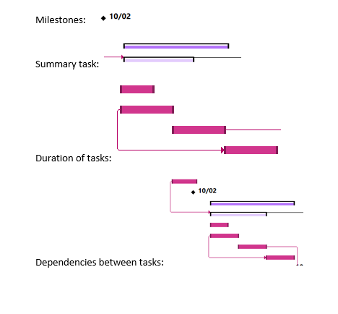

Figure 2 Label for Gantt Chart in Microsoft Project

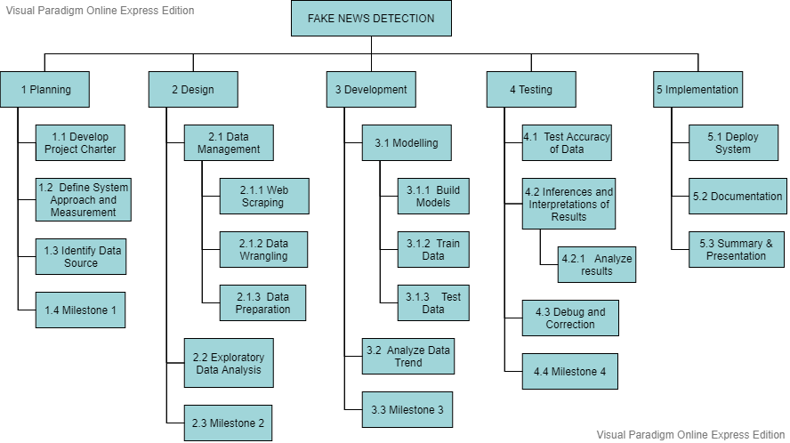

Figure 3 Work Breakdown Structure

**Risk Identification Chart (Quality, Cost, Time)**

|  |  |  |  |
| --- | --- | --- | --- |
| **Control Element** | **What is likely to go wrong?** | **How and when will I know?** | **What will I do about it?** |
| Quality | The system cannot detect the false content accurately | The performance metric for this system is based on the performance execution of the algorithm and if the performance of the algorithm does not perform effectively, the result executed is poor. | Should test the algorithm frequently until the algorithm achieves a good result. |
| Cost | The project cost spent reaches the budget limit. | By the review of the cost project report. In the case of extra expenditure, the expenses involved reaches the budget limit. | Must ensure that spending are chosen carefully and reviewed frequently to avoid project cost reaches the budget limit. |
| Time | The testing part is a time consuming and can be a potential for the project deadline to be extend. | The result of the algorithm does not precisely accurate to detect the false content and the project deadline is around the corner. | Try to shorten the critical path project schedule by fast tracking the tasks and crashing the problems. Next, overlaying the plans for the project. Team members should frequently monitor the progress of the project and change the plan by regular opinions. |

**Responsibility Assignment Matrices (RAM) :**

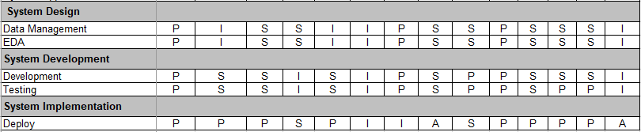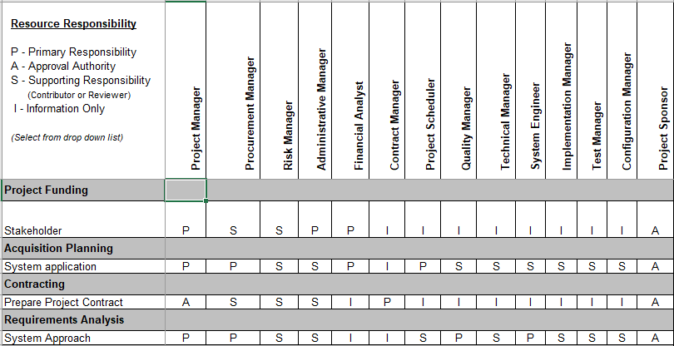

Figure 4 Responsibility Assignment Matrices

**Member’s roles and responsibilities**

|  |  |  |
| --- | --- | --- |
| Member’s Name | Roles | Responsibilities |
| Elle Aliz | Project Manager | The Project Manager is accountable to the Project Director for all the project office management related activities. The Project Manager plans, guides, and oversees the day-to-day internal activities that support the Project Office, and assists in the development of the master project schedule and all other project work plans. The Project Manager is accountable for the development, maintenance, and adherence to the Project Office infrastructure and supporting methodologies that are in compliance with OSI Best Practices and policies. |
| Gion Min Ming | Procurement Manager | The Procurement Manager oversees and manages the generation of the RFP or RFO and other solicitation documents. Other areas of the project office may be assigned responsibility for specific sections, but the Procurement Manager is responsible for integrating all the pieces and ensuring consistency and continuity throughout the entire procurement process and conforming to procurement standards, rules, and regulations. This includes managing the RFP or RFO development, preparing and maintaining procurement schedule, coordinating contract negotiations and managing evaluation of proposals or offers and selection of vendor. |
| Amirah Nabilah | Risk Manager | The Risk Manager is responsible for managing and tracking risks and risk mitigation/contingencies on the project. The Risk Manager also monitors prime contractor risk management efforts to ensure they do not adversely impact the project. The Risk Manager manages and tracks potential and active risks, maintain the risk management tool and documentation information, leads risk identification sessions for the project, monitors prime contractor risk management efforts, and participates in division-level risk management activities for risks that cross project boundaries or are beyond the project’s control |
| Elle Aliz | Administrative Manager | The Administrative Manager directs the administrative staff, coordinates tools and services training, ensures that the administrative staff adhere to processes and policies, leads the cost management effort including: sponsoring cost budgeting and tracking activities, facilitating communication on fiscal status, and ensuring the project cost tool and supporting documentation is maintained. The Administrative Manager also provides reports, recommendations, and status on the project budget and expenditures, initiates corrective action, and re-planning activities. |
| Gion Min Ming | Financial Analyst | The Financial Analyst is responsible for supporting the Administrative Manager by managing and tracking project budget/costs, coordinating/preparing budgetary documents. This includes reconciling the accounting and Work Breakdown Structure cost management processes and developing financial management policies and procedures. The Financial Analyst also provides support in project solicitations, evaluations, and award processes and assisting in the evaluation of the cost and administrative sections of the proposals based on the criteria in the Evaluation Plan. |
| Elle Aliz | Contract Manager | The Contract Manager is responsible for managing and tracking the Prime Contractor and consulting contracts for the project. This includes negotiating amendments, reviewing work authorizations and invoices, and ensuring that all contractual terms and deliverables are met. |
| Amirah Nabilah | Project Scheduler | The Project Scheduler is responsible for coordinating and managing inputs to the project plan. This includes tracking progress against project schedule, merging and identifying dependencies and risks between the project schedule, tracking progress on prime contractor's schedule and counties' schedules. |
| Gion Min Ming | Quality Manager | The Quality Manager is responsible for overseeing and ensuring both product and process quality for the project office as well as for the Prime Contractor. The Quality Manager provides insight into the project and contractor methods of doing business by reviewing process and product activities for adherence to standards and plans. |
| Thitthima | Technical Manager | The Technical Manager is responsible for the day-to-day activities of state and vendor technical staff who are engaged in the technical management aspects of the project. The technical manager and system engineer co-lead in the technical disciplines of the project. One of the key roles of the Technical Manager is to partner with other IT managers to acquire appropriate technical assistance for such areas as enterprise architecture, database, software development, security, testing, configuration management, change management, release management, and other technical areas of the new system. The Technical Manager, along with the system engineer, will provide leadership and support to technical staff that are augmented to the project throughout the project life cycle.  The Technical Manager will also provide technical support to the Project Director, Project Manager, and other managers in the Project Office to establish and execute technical policies, processes, and procedures. |
| Thitthima | System Engineer | The System Engineer is a co-leadership position with the Technical Manager in overseeing the technical aspects of the project and is a direct support to the Technical Manager. The System Engineer provides industry best practices and disciplines that will be applied and tailored to suit the processes and culture of the state technical environment.  The System Engineer will support the Technical Manager primarily in providing technical leadership towards the development and tracking of the system business requirements and interfaces, assisting with technical analyses, and ensuring the final system meets all stated requirements. The System Engineer will also be responsible for the following: tracking and managing the requirements for the new system and any changes to the requirements, providing exposure to project stakeholders on new technologies and processes relevant to the project, providing training of the evaluation team, and holding technical simulations of the project as needed. |
| Thitthima | Implementation Manager | The Implementation Manager will be responsible for the implementation portion of the project. The Implementation Manager will provide implementation management leadership through planning, organizing, coordinating, and monitoring implementation activities |
| Amirah Nabilah | Test Manager | The Test Manager is responsible for coordinating the testing of the Prime Contractor's system. The Manager works with the Quality Management staff to design test cases and data that will best represent "real-life" scenarios for the system. The Test Manager is also responsible for coordinating interface tests with other organizations as needed. They plan, monitor, and evaluate prime contractor test plans, problem reporting and resolution process. |
| Amirah Nabilah | Configuration Manager | The Configuration Manager is responsible for supporting the Technical Manager by administering the Configuration Management process, coordinating the control of all non-product related configuration items, working with the contractors to manage and coordinate the product related configuration items, assisting the System Engineer in maintaining the requirements database, and conducting configuration audits. The Configuration Management also leads work with project stakeholders, in particular, the Change and Release Management Group for approval to release programs and configuration modifications into the production environment. |
| Elle Aliz | Project Sponsor | The Project Sponsor has overall authority for the project. The Project Sponsor provides vision and direction for the project, provides policy leadership, assists in removing barriers and supports change management initiatives, participates in the Executive Steering Committee, and provides support to the Executive Steering Committee as needed. |

**Project Planning Summary:**

Modules/Components Budget Schedule Responsibility

|  |  |  |  |
| --- | --- | --- | --- |
| **Modules/Components** | **Budget (RM)** | **Schedule** | **Responsibility** |
| False content data | 3000 | 13 October 2020 – 13 November 2020 | Collect Data |
| Software environment | 400 | 10 November 2020- 15 January 2021 | Development process |